INFOdation internship
Hồ Thị Kim Thoa
Exercise 1: Github

1. Create/login your GitHub account.
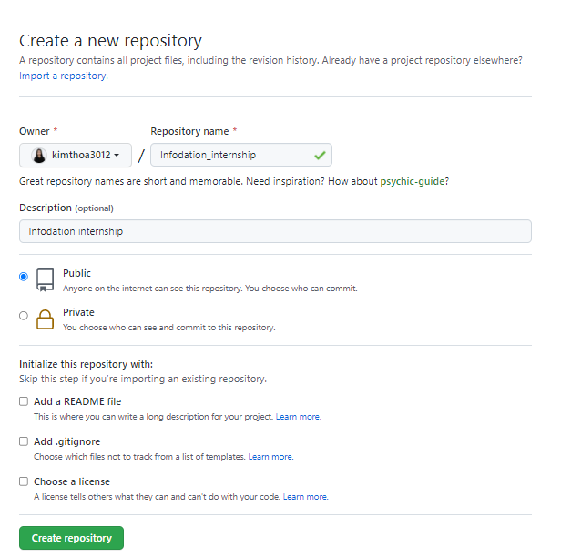
2. Create a new repository, add an account: hung.nguyen@infodation.vn to this repository.
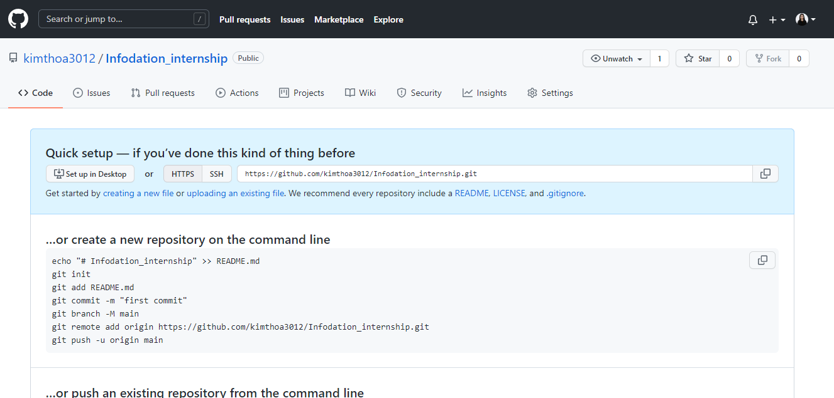

3. Introduce yourself in a text file and commit to the master branch
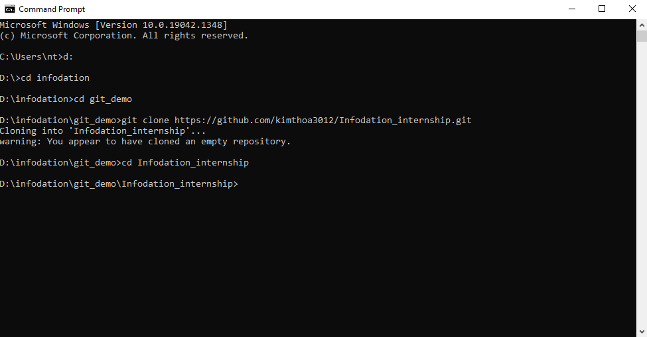

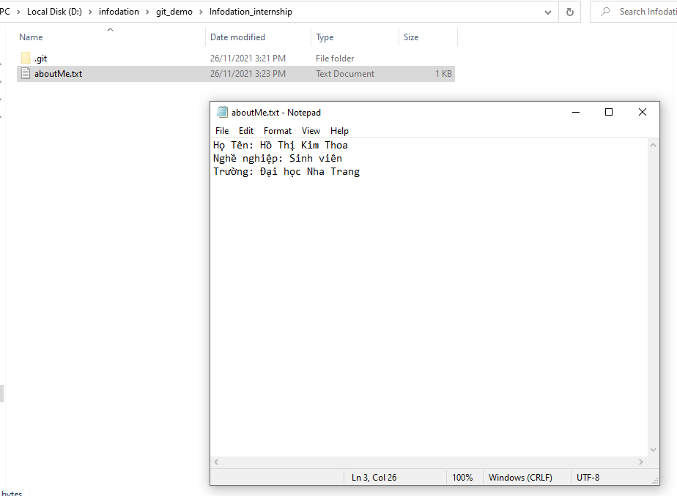
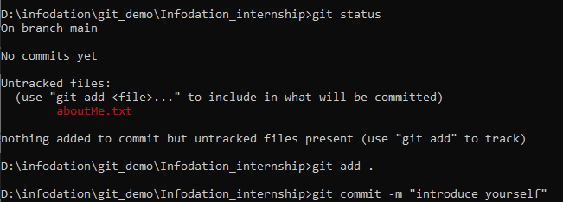
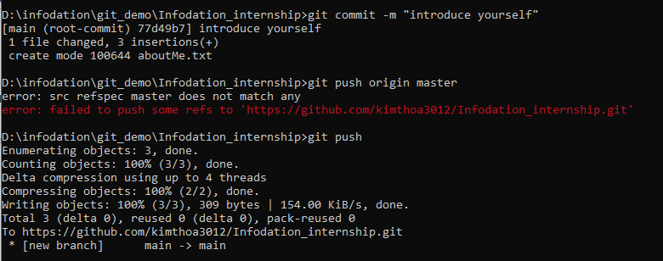
4. Create a develop branch from the master branch
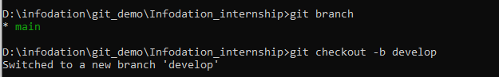
5. Create a feature with your name from develop branch
6. Commit any favorite sources to this feature.
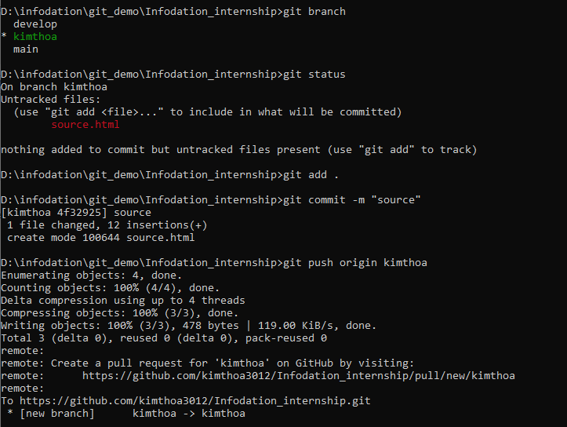
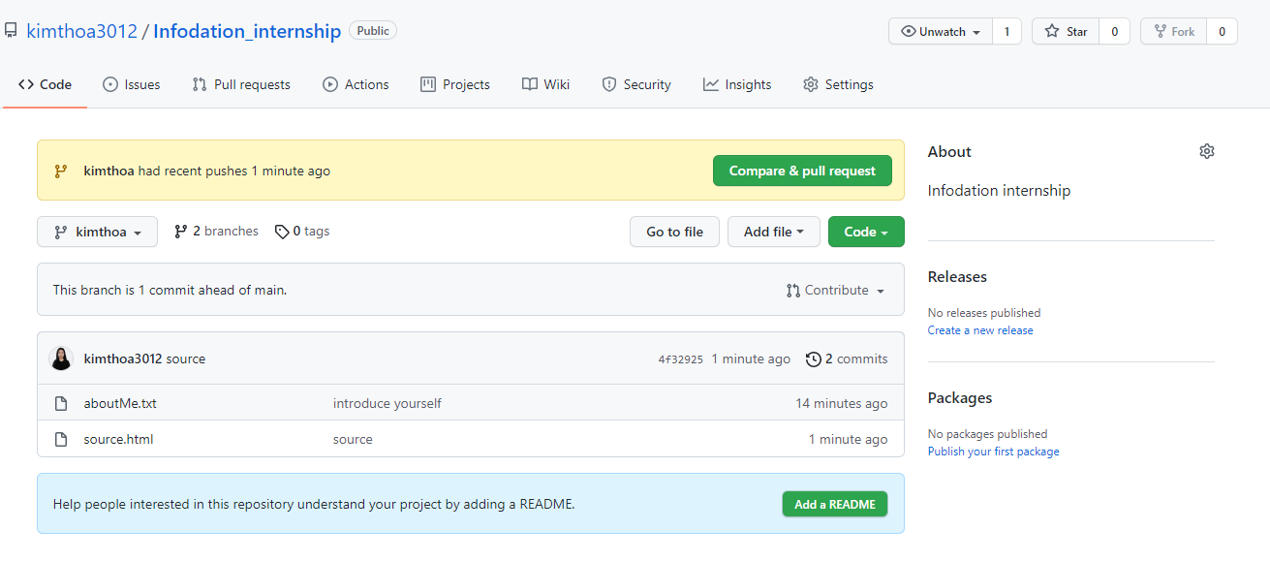
7. Create a new feature with the name: Exercise result from develop branch.
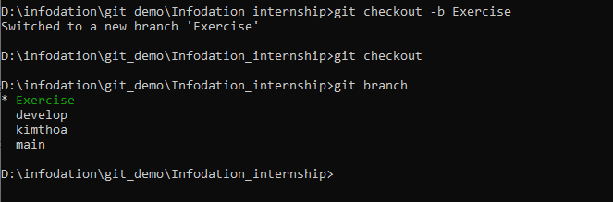
8. Take photos/evidence for these above steps, commit source to the exercise branch
9. Pull two requests for two features: your name to develop and exercise to master branch.
10. Notify the tutor.

